DATA DRIVEN DASHBOARD

# OVERVIEW

Data visualisation is an important part of any information system. Gravitas AI’s clients are looking for a visualisation of their customer analytics data collected as a result of customer interaction with Gravitas AI’s flagship product, its powerful and versatile chatbot. Your task is to create this dashboard which represents various data points along with their graphical representation.

# GOALS

1. Create a dashboard as per the designs shared in the mockup. (Mockups are the end of the document)
2. The dashboard should be responsive to various standard screen sizes.

# SPECIFICATIONS

The following frameworks/languages should be used: Angular 6+ or ReactJs, HTML5, CSS3, Bootstrap 4.6+. Any free icons library can be used such as Font Awesome etc. The icons can be different from what have been shared in the mockups. Any free charts library can be used for chart visualisation such as ChartJs etc. Any dummy data should be used for simulation and visualisation of the project.

# MILESTONES

## Home Page

Creating visualisation of the dashboard home page

## Data Details

Creating the data details page. This page will appear when we click on a data card from the dashboard.

## 

## Responsive Design

Making the design responsive to all standard device sizes

## Animations

Adding on hover color animations for data cards on the dashboard

## Bonus/Optional Milestone

Creating a web api using NodeJs and fetching data needed on the dashboard from this api.

# MOCKUPS

Please find the mockups below and the google drive link to access the individual files:

https://drive.google.com/drive/folders/1kBTV9ffQb_ITd9GSAkKV3ETE9o64dBuq?usp=sharing

## Home Page

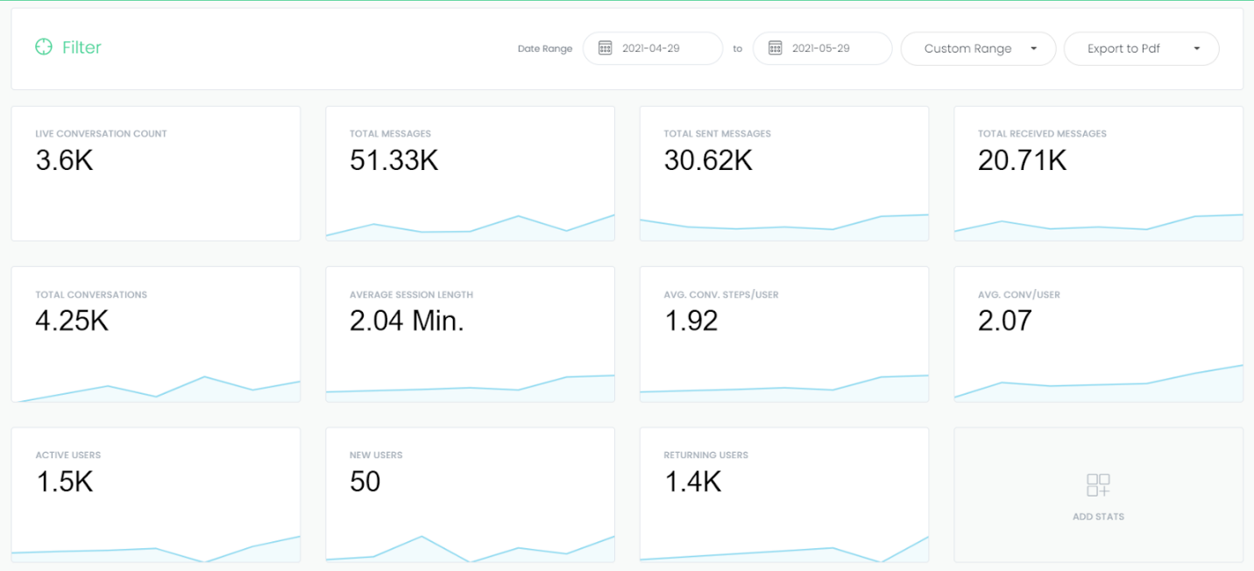

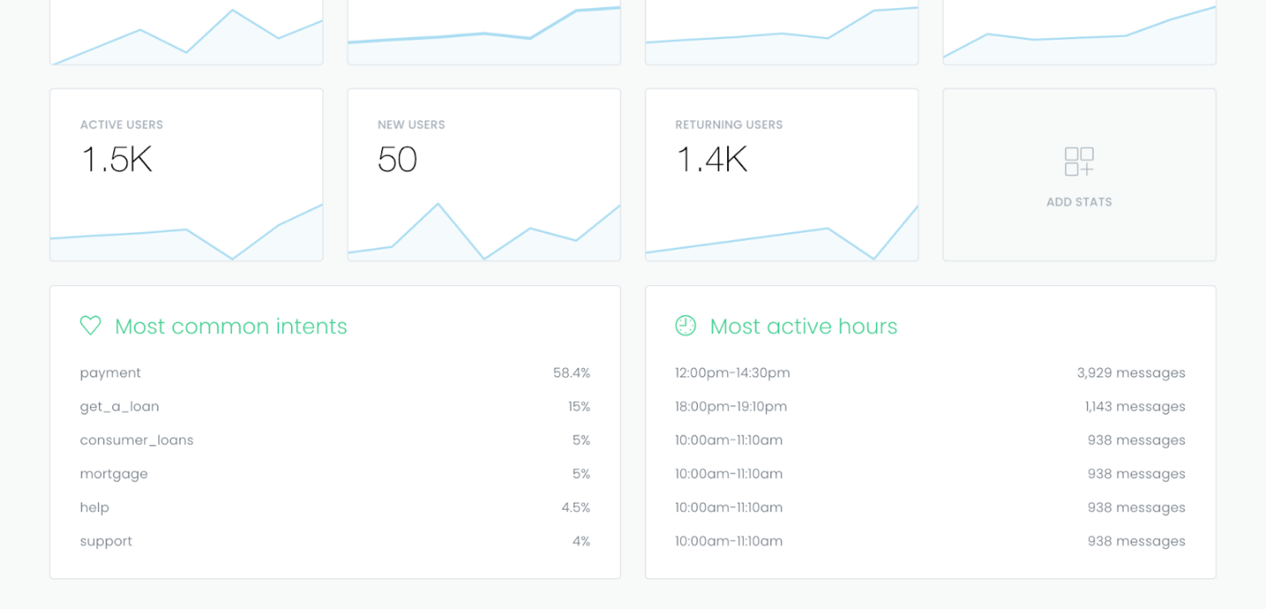

## Data Details Page

